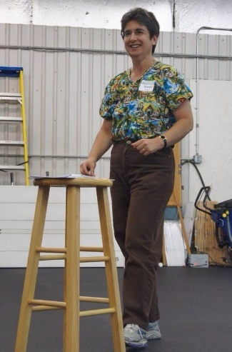
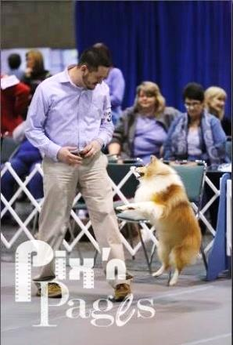
Brenda Riemer, Ph.D.
Mental Skills Training For Competitive Canine Handlers

Brenda’s first seminar on the West Coast! Join us for a Sport Psychology
weekend with a multi-OTCH & HIT competitor/instructor/coach

Sat. April 16 & Sun. April 17, 2016

Saturday & Sunday Working Spot with Dog $200 (Limit to 10)
Saturday & Sunday Auditor $150 / One Day Auditor $85

About Brenda
Brenda Riemer earned her PH.D. in Sport Psychology from Michigan State University in 1996. Since then, she has taught Sport Psychology at the college level and has worked with college and high school athletes. In addition, she has worked with top obedience competitors on their mental skills. Brenda’s current dogs include Sheltie, Liza, UDX4, OM8, RE, VER and 71 OTCH points, plus Dachshund, Zelda, BN (who’ll be making her Novice debut soon). Brenda’s prior dogs have earned OTCHs, UDXs, OGMs as well as other obedience, rally and agility titles. Brenda’s spouse with Golden Retriever, Packer, recently finished 3rd at the Classic and will compete at Westminster in 2016. Brenda currently teaches at Eastern Michigan University.

An email to Brenda from a previous seminar attendee who shows in obedience and conformation:

Hi Brenda, I wanted to give you some feedback on your seminar. I am so very competitive, that if I'm not "winning" or taking the points in conformation, or placing 1st or 2nd in the obedience ring, I feel like a failure.

Well, after your seminar, on the way to my next dog show, I noticed that my leg muscles were tense-didn't know I did that before! My shoulders and arms were tense too. So I tried some of your suggestions to de-tense myself, in addition doing some visualizing.

While grooming and getting ready, I started feeling nervous again, so I used the breathing technique. I also did short visualizations. When I went into the ring I didn't focus on anything but "us as a team" and the judge of course. I stood tall not hunched over, I focused on what my trainer had said, and moved him at a good pace while I hummed and counted under my breath.

We took second in our class and then reserve. No points but I felt amazing when I came out of the ring! I had accomplished what I set out to do – with your help, of course. It was a great feeling!

I took your seminar to heart and it really helped me. Now I keep practicing and setting small goals, not focusing too much on the winning, but being happy and a team with my boy in the ring, and it shows.

Thank you so much for the seminar and info!

About the seminar
The philosophy behind this mental skills seminar is the fact that people are not born with
perfect mental skills for the dog sports ring, just as dogs are not born knowing how to perform
perfect heeling, fronts or finishes. Ring nerves can be overcome with practice – whether
competing in conformation, obedience, rally, agility or any other dog sport.

Saturday will include:
- What competition is
- Why we can experience ring nerves
- Psychological skill training
- Ways to reduce stress and anxiety
- Imagery, goal setting and other related topics
- With multiple exercises for everyone to do during the seminar

Sunday will include:
Up to 10 dog / handler teams will prepare to enter the ring, do a brief run-through and then
exit the ring in a mock trial. Brenda will coach and support the handler. Other seminar attendees will play the parts of judge, steward, audience, etc. It will be a great opportunity
for everyone to see Brenda’s mental training skills put into practice.

More information
The seminar will be held at Family Dog Training Center’s 9,300 s.f. indoor facility at 1515 Central Ave. S. in Kent, WA. Seminar hours: 9 am to 4 pm. There will be plenty of room for participants, auditors and dogs registered for the seminar. (Auditors will need to leave their dogs in vehicles or at home.) Seminar and working spots will fill in the order full payment is received. No spots will be held without payment. A waiting list will be maintained. Refunds only if the seminar is canceled. If you cannot attend, you may sell your spot to a friend, provided you give us written notice. Morning and afternoon refreshments and lunches (sandwich fixings, soups and salads), along with fruits, snacks and beverages will be provided each day. RV parking onsite is available (no hook-ups). A list of nearby motels will be provided with registration confirmation. See the back of this page for registration, or visit our website: www.familydogonline.com

1515 Central Ave. S., Kent, WA 98032
FamilyDogOnline.com / Info@FamilyDogOnline.com
(253) 854-9663 voice / (253) 850-3647 fax

Brenda Riemer Seminar Registration Form

Participant_________________________________________________________________________________________

Street Address______________________________________________________________________________________

City, State, Zip______________________________________________________________________________________

Day Phone_________________________________________ Cell Phone_______________________________________

Email______________________________________________________________________________________________

CHECK ALL THAT APPLY
*There are only 10 TOTAL working spots available. These dogs will be set up to do a rally or obedience run through on SUNDAY. Working handlers will receive a questionnaire a few weeks prior to the seminar. Limit of one dog per working handler.

_____Saturday & Sunday WORKING Spot with Dog*: ___$200

_____Transfer my registration to an AUDITOR spot (and refund the difference) if working spots are full.

_____Return my payment if working spots are full.

_____Saturday & Sunday AUDITOR WITHOUT Dog: ___$150

_____One Day Only AUDITOR WITHOUT Dog: ___Saturday $85 ___Sunday $85

_____Please send me info about motels & hotels in the area _____Please send me info about RV parking on site

Amount Enclosed: $__________________US FUNDS Circle Payment Method: Check / Discover / Visa / MasterCard / Cash

For credit card payments: Print Name on Card______________________________________________ Expiration Date ______________________
Card Number___________________________________________________ Signature ___________________________

By providing your credit card information you authorize Family Dog Training Center to process your payment specified upon receipt.

PARTICIPANTS MUST READ AND SIGN BELOW

I understand that there will be no refunds issued for any reason (other than seminar cancellation); however, a participant who is unable to attend may send someone to take his or her place provided permission is given in writing and a copy is submitted to Family Dog Training Center. Due to space constraints participants should leave their dogs at home. Returned or NSF checks are subject to a $30 bank processing fee. Declined credit cards that result in late payment due to delayed processing are subject to a $30 late payment fee.

I agree to indemnify and hold harmless Brenda Riemer, Kathy Lang Dog Training Services, Inc., The Family Dog Training Center, and its owners, board of directors, officers, agents, employees, instructors, and staff members, from any and all claims, demands, actions, causes of action or liability of any kind whatsoever, for death, personal injury or property damage in any way proximately caused by myself, my family members, my friends and/or any animal belonging to, or brought onto the premises by myself or any member of my family or my assigns. I further agree, on behalf of myself, my family and my assigns, to assume complete and sole responsibility for any and all actions of any animal belonging to, or brought onto the premises by myself, any member of my family or my agents or assigns.

Participant’s Signature______________________________________________________________________Date________________________
Keep a copy of this page for your records. Mail with payment to:
Family Dog Training Center, 1515 Central Ave S, Kent, WA 98032 / (253) 854-9663 / Office@familydogonline.com / familydogonline.com
We will send you a confirming email once we receive and process your payment.

